**Engaging the Modern Workforce: How Companies are Keeping Employees Happy and Motivated**

The modern workforce has become more diverse and complex, with new technologies, remote work, and flexible working arrangements transforming the way we work and interact with one another. Organizations must adapt to these changes by embracing innovative strategies that foster collaboration, communication, and inclusivity among employees of different backgrounds, skills, and experiences. This requires a shift from traditional hierarchical structures to more agile, decentralized, and adaptable frameworks that empower individuals to contribute, grow, and thrive. Companies continually look for new ways to keep their employees happy and motivated, recognizing that their success is closely tied to employee satisfaction and retention.

In this article, we will explore what remote work is all about and what strategies companies use to keep employees happy and motivated in the modern workforce.

## **First Things First**

### **Understanding Remote Work and Employee Engagement**

Remote work has been on trend for years and will most likely continue. Many realize virtual work's advantages as companies and employees settle into this modern workforce. And it’s no surprise.

Many remote employees are happier and highly productive. Plus, companies that offer remote and flexible work options attract top talent, helping businesses hire, and retain a competitive workforce.

But maintaining and managing a remote workforce can be challenging for some. How do you ensure your remote employees are successful? Start by keeping them engaged, no matter where they're working.

### **Why Remote Work?**

At the onset of the pandemic, many traditional-minded leaders hesitated to invest and transition to remote work, but now, most people agree that remote work has compelling advantages.

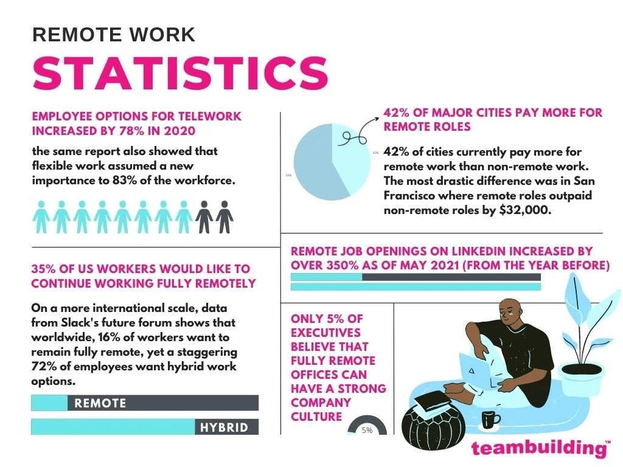

[Source](https://teambuilding.com/wp-content/uploads/2022/03/remote-work-statistics-1.jpg)

#### **Benefits of remote work include**:

1. **Increased flexibility**: Allows employees to work when and where they feel most productive, which can help improve work-life balance and reduce stress.
2. **Reduced commuting time and costs**: Eliminates the need for employees to commute to an office, which can save time and money on transportation and related expenses.
3. **Increased productivity**: Remote workers often report being more productive because they can work in an environment conducive to their personal work style and preferences.
4. **Access to a larger, top talent pool**: Allows companies to hire talent from anywhere globally, giving them access to a larger pool of skilled talent.
5. **Improved employee retention**: Remote work is often seen as a desirable perk, and offering it can help companies attract and retain top talent.
6. **Reduced overhead costs**: Reduce office space requirements and associated costs, such as rent, utilities, and office equipment.
7. **Improved environmental sustainability**: Helps reduce carbon emissions by eliminating the need for employees to commute.

Studies have shown that most companies are leaning towards remote work for the abovementioned reasons. But let’s keep in mind that remote work has its own set of challenges.

#### **Potential challenges of remote work include**:

1. **Social isolation**: Employees may miss the social interactions and sense of community of working in an office.
2. **Communication challenges**: Communication can be more difficult when working remotely, and misunderstandings or miscommunications can occur more often.
3. **Management challenges**: Some managers may struggle to effectively lead a remote team due to their reluctance to adopt technology and adapt to remote work practices
4. **Distractions at home**: Working from home can be distracting, especially if there are children, pets, poor lighting, uncomfortable seating, cluttered workspaces, etc.
5. **Technology issues**: Technical difficulties, such as poor internet connectivity or software malfunctions, can be more challenging to troubleshoot when working remotely.
6. **Compromised work-life balance**: Remote workers may have difficulty separating work and personal life, leading to longer work hours and a lack of boundaries.

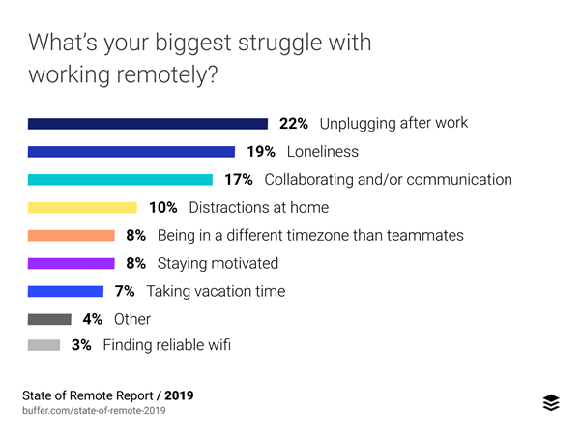

[Source](https://www.intuition.com/wp-content/uploads/2021/02/state-of-remote-work-report.png)

It's important to note that although some remote workers experience these challenges, many find remote work gratifying.

## **How Companies are Keeping Employees Happy and Motivated**

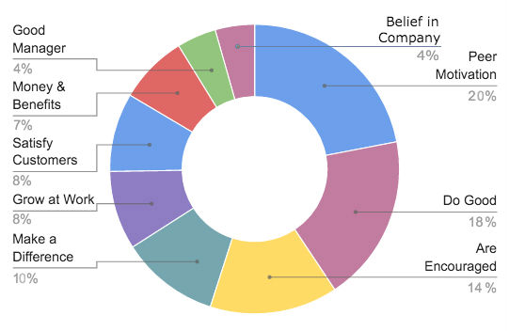

[Source](https://diyfqze5s92fh.cloudfront.net/publish-web/2016/Apr/Chart_2-1460677157444.jpg)

Here are some ways companies are keeping employees happy and motivated, especially in remote work environments:

### **Building a Positive Work Culture**

Building a positive work culture that supports remote work means creating an environment where employees feel supported, engaged, and connected to their colleagues and the organization's goals. In addition, a positive work culture should foster collaboration, productivity, and employee well-being.

Here are some key factors to consider when building a positive work culture that supports remote work:

#### **Open Communication**

Clear and regular communication is essential for building a positive work culture. Remote employees should feel informed about company news, updates, and goals. Leaders should also encourage open communication and feedback among team members.

#### **Trust**

Trust is critical when working remotely. Leaders should trust their employees to work independently and hold themselves accountable. This trust can be fostered by setting clear expectations, offering support when needed, and recognizing employee contributions.

#### **Flexibility**

Remote work often provides greater flexibility than traditional office environments. Leaders can build a positive work culture by supporting flexible schedules, acknowledging and accommodating employee needs, and promoting work-life balance.

#### **Recognition**

Recognizing employees for their work and contributions is essential to building a positive work culture. Leaders should create a culture of appreciation by acknowledging employee successes, celebrating milestones, and promoting a sense of belonging.

#### **Social Connections**

Remote work can be isolating, so leaders should prioritize cultivating interaction among team members. It can be accomplished through virtual team-building activities, social events, and informal communication channels.

### **Offering Opportunities for Career Development and Growth**

Offering opportunities for career development and growth means providing employees with resources, support, and training to help them advance in their careers while working remotely. It involves investing in employees' professional development, providing access to career advancement opportunities, and offering feedback and coaching to help employees reach their full potential.

Below are practical ways to encourage career development and growth in a remote work environment:

#### **Provide Access to Learning and Development Resources**

Remote workers should have access to learning and development resources, such as online training, webinars, and e-learning platforms. These resources can help employees upskill and stay current with industry trends.

#### **Offer Mentoring and Coaching**

Remote workers may miss out on the in-person mentoring and coaching opportunities more readily available in traditional office settings. Leaders can support employee career development by offering regular coaching and mentoring sessions via video conferencing or other communication tools.

#### **Support Career Advancement**

Remote workers should have the same opportunities for career advancement as their in-office colleagues. Leaders should work with remote employees to identify career goals and provide virtual support and resources to help them reach those goals.

#### **Provide Regular Feedback and Performance Evaluations**

Remote workers may feel isolated and disconnected from their team and organization. Regular feedback and performance evaluations can help remote employees understand how their work fits into the larger organization, identify areas for improvement, and receive recognition for their contributions.

#### **Encourage Networking and Collaboration**

Remote workers may miss networking opportunities in traditional office settings. Leaders can support remote employees by encouraging virtual networking opportunities like video calls with colleagues, virtual team-building activities, and online discussion forums.

### **Non-Traditional Perks**

Non-traditional Perks aim to provide unique benefits and incentives to remote employees beyond the traditional bonuses offered in a typical office setting. These perks can help remote workers feel valued, motivated, and engaged. Non-traditional perks range from flexible work arrangements to wellness programs and technology allowances.

Some examples of non-traditional perks for remote workers include:

#### **Flexible schedules**

Remote workers may appreciate having more control over their schedules, so offering flexible work hours can be valuable. This can allow remote workers to take breaks when needed, work around family commitments, or take care of personal errands during the day.

#### **Wellness programs**

Remote work can be isolating and lead to a sedentary lifestyle, so employers can offer wellness programs to support remote employees' physical and mental well-being. This can include virtual fitness classes, mindfulness sessions, and access to mental health resources.

#### **Learning and development opportunities**

Offering opportunities for learning and development can help remote workers grow professionally and feel more connected to their company. This can include virtual training sessions, access to online courses, or mentorship programs.

#### **Home office stipend**

Remote workers may need to set up a home office or upgrade their equipment to work effectively, so offering a stipend can be a valuable perk. In addition, this can help cover the costs of equipment, furniture, and other necessary expenses.

#### **Subscription services**

Employers can offer subscription services that remote workers can use to stay productive and focused, such as access to virtual assistants, productivity tools, or online learning platforms.

Offering non-traditional perks to remote workers can help employers attract and retain top talent, enhance employee satisfaction and productivity, and demonstrate a commitment to supporting work-life balance and well-being. In addition, by tailoring perks to the needs and preferences of remote workers, employers can create a positive work culture and build a solid remote workforce.

### **Social Responsibility Initiatives**

This aims to provide opportunities and resources for remote employees to engage in activities that promote social responsibility, sustainability, and community involvement. Social Responsibility Initiatives can include virtual volunteering opportunities, corporate social responsibility campaigns, employee giving programs, community outreach programs, and sustainability initiatives.

#### **Virtual Volunteering Opportunities**

Employers can offer virtual volunteering opportunities that allow remote employees to participate in community service projects from their home offices. This can include online mentoring, virtual fundraising, or remote pro-bono work.

#### **Corporate Social Responsibility Campaigns**

Companies can arrange campaigns that align with their values and endorse a cause that strikes a chord with their employees. These initiatives include fundraising drives, charitable donations, or awareness-raising activities.

#### **Sustainability Initiatives**

Remote work can help reduce an organization's carbon footprint, but employers can take it further by implementing sustainability initiatives that promote eco-friendliness among remote employees. This can include recycling programs, energy-efficient office equipment, or eco-friendly office supplies.

#### **Employee-giving Programs**

Companies can provide programs that inspire remote employees to donate to their preferred charitable causes. Such initiatives include donation matching, micro-donations, or charitable gift cards.

#### **Community Outreach Programs**

Employers can partner with local organizations and charities to organize community outreach programs that involve remote employees. This can include virtual mentoring, online tutoring, or virtual career fairs.

### **Leveraging Technology**

The COVID-19 pandemic has accelerated the need for leveraging technologies to support remote work environments. Leveraging technology means providing the necessary technological resources and tools to enable employees to work effectively and efficiently. This can include software, hardware, communication tools, and cloud-based platforms that facilitate remote work collaboration and productivity.

With more employees working from home than ever, companies are investing in technologies that support remote work, such as virtual private networks (VPNs), video conferencing software, team collaboration tools, and cloud storage solutions. These technologies enable remote workers to stay connected with their colleagues, access essential company data and resources, and collaborate on projects regardless of location.

## **All in All**

In the rapidly evolving world of work, the importance of adapting to new trends and practices cannot be overstated. With the increasing popularity of remote work, companies must provide a positive work culture for their employees to thrive. This requires a shift in mindset and the implementation of new policies and practices that address the needs and preferences of remote workers.

Effective communication, regular check-ins, and setting clear goals and expectations are crucial for keeping remote workers engaged and motivated. Additionally, offering opportunities for career development and growth and non-traditional perks, such as wellness programs and flexible scheduling options, can help employees feel valued and invested in their work.

Social responsibility initiatives and leveraging technologies can enable companies to create a positive impact on their employees and society at large. By providing resources and tools that support remote work collaboration and productivity, companies can improve their bottom line while demonstrating a commitment to their employees' well-being.

Companies that prioritize their employees' needs and well-being are better equipped to retain top talent and succeed in the modern workforce. By adapting policies and practices to the changing work landscape, companies can create a positive work culture that fosters productivity, engagement, and innovation.